# Ordering Your Free Photo Package

1. Go to <https://graduation-services.edeandravenscroft.com/graduation/>
2. In the Institution Details section, enter University of Birmingham and select it from the drop-down list.

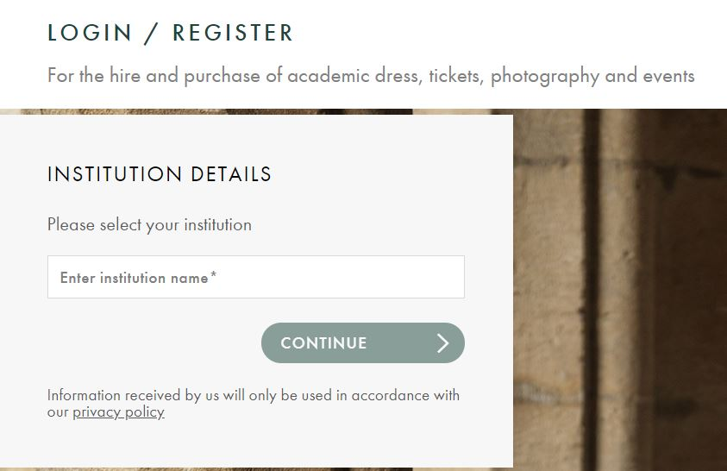

1. Click Continue.
2. Select your ceremony time (you can check the time of your ceremony on [our July 2021 graduations webpage](https://www.birmingham.ac.uk/graduation/graduation-class-of-2021.aspx)).

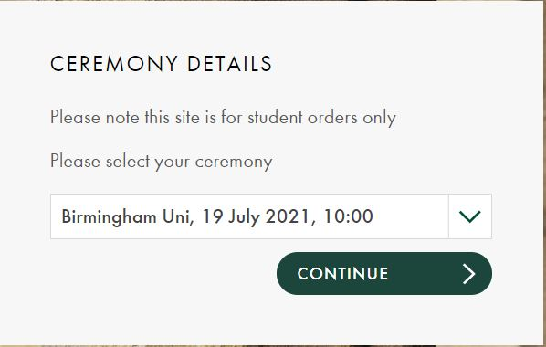

1. Click Continue.
2. Select your award/degree.

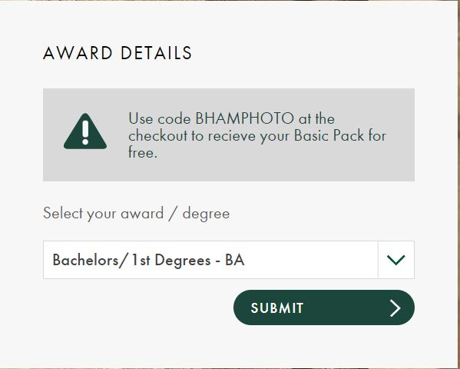

1. Click Submit.
2. Review the information you have provided about your ceremony.

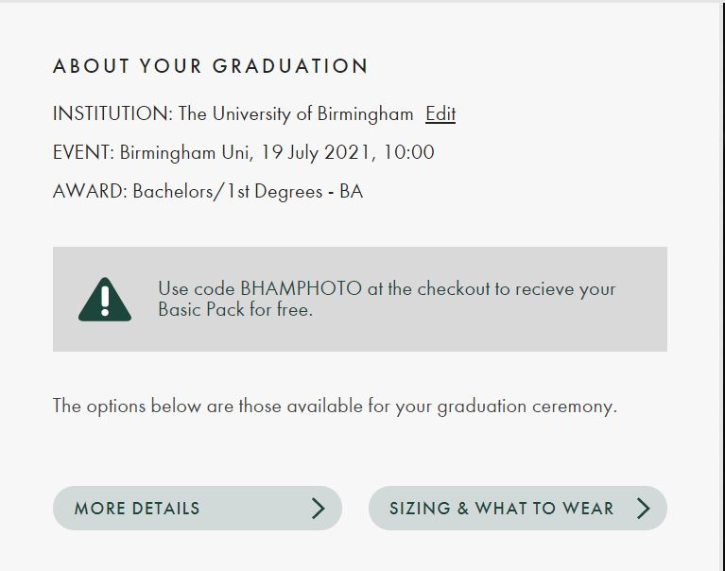

1. Click Arrange Your Graduation – Photography – View Options – Photography Packages – Basic Pack – More Details.

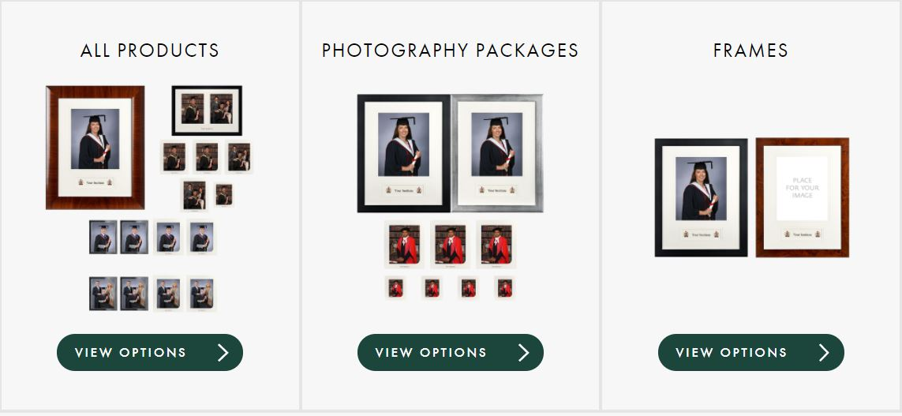

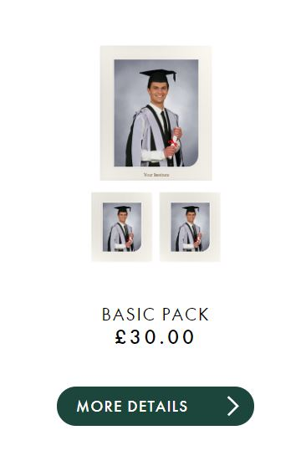

1. Select Paper – Satin.
2. Select Quantity – 1.
3. Click Add to Cart.

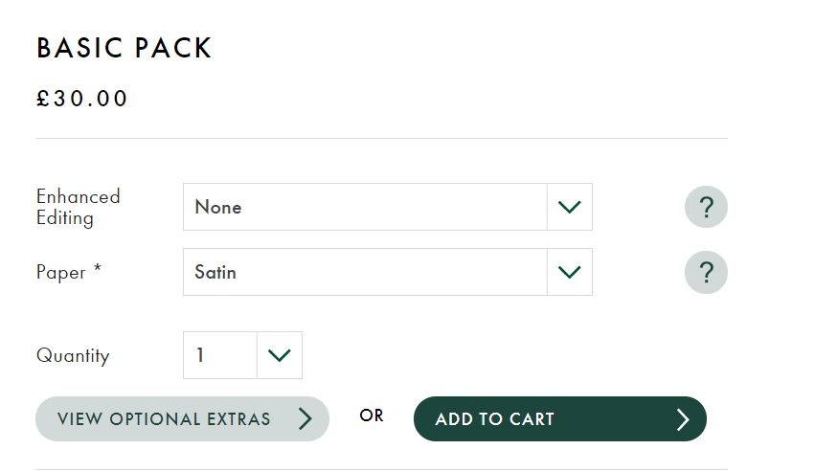

1. Click Proceed to Checkout.
2. Choose a sitting time when you would like to have your photo taken – make sure this doesn’t clash with your ceremony time. If you want to take your photos before the ceremony, make sure you leave sufficient time to get to your ceremony after your photos. If you want to take your photos after the ceremony, leave enough time to get from your ceremony to the Great Hall before your photo slot begins.

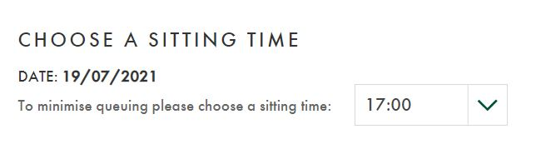

1. Click Proceed to Checkout.
2. Select Apply Discount Code.
3. Enter the code BHAMPHOTO
4. Click Apply Discount.

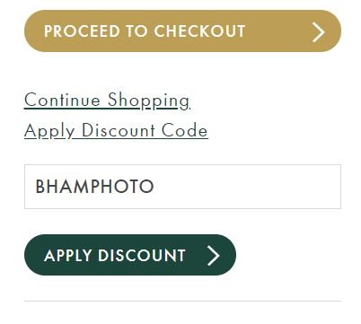

1. Your order will be updated to £0.00.

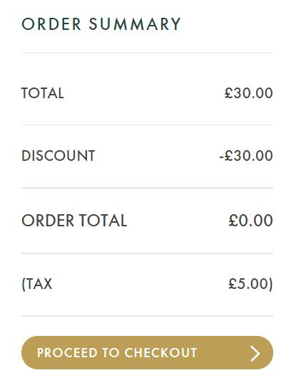

1. Click Proceed to Checkout.
2. On the next screen, either create a new Ede and Ravenscroft account or login to your existing account.

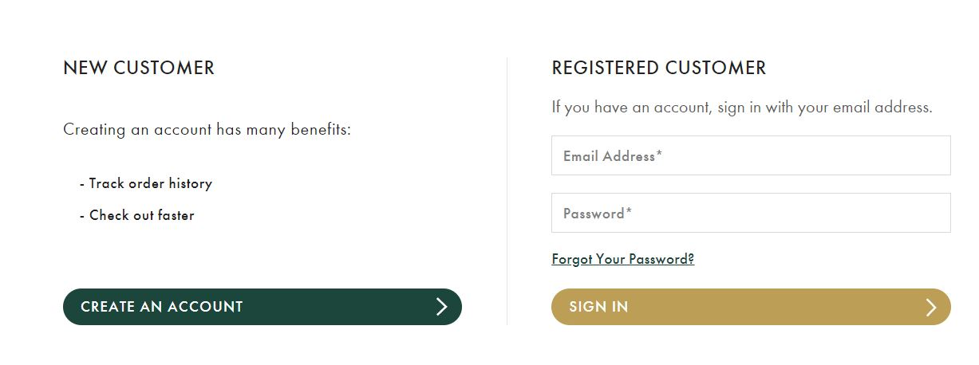

1. Enter your delivery address information.
2. Click Continue to Payment.
3. Read the terms and conditions and tick the box to confirm that you’ve read them.

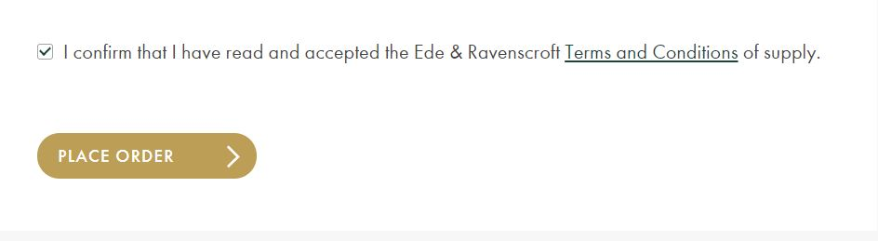

1. Click Place Order.